**“Know Your Brew”**

**A COFFEE ANALYSIS PROJECT**

**PROPOSAL**

**Presented By:**

**Aparna Paul, Saifee Dalal, Sarah Small, and Courtney Charles**



**OCTOBER 30, 2018**

**Motivation**

We are ready to get into the coffee retail business! However, we have to do our homework. Winter time is here and coffee drinkers are ready to pour up their hottest cup of coffee at coffee retailers and stores across the US. Guess what? We can use Big Data Analysis tools to gather data and analyze coffee trends?

- Which coffee types and brands are the most popular in the US?

- How does a cup of coffee make coffee drinkers feel?

- Where geographically are the most coffee drinkers in the US?

- Compare popular coffee types and ranking in online sources and social media.

- Observe the change in trends over time.



**Dataset, Algorithms and Tools**

**Dataset :** Yelp API, Google Maps API, Weather API, USDA QUICK STATS DATA, Twitter API, and World Atlas Data

Tracking certain keywords and collecting data like user information, geolocation and the text.

**Algorithms:**

1) YELP API for coffee place based on zip code.

2) Determine the popularity of coffee based on the number of tweets.

3) Correlation between coffee consumption and weather.

4) Scrape websites for analysis on coffee drinking.

5) Apply likeability analysis on each like by computing the average likeability score of each like

and then compute the average likeability score of all the likes collected. Also do likeability

analysis on Internet data by using Yelp API.

6) Leaflet: worldwide trend of production and export.

7) Scrape: of image, coffee news and most caffeinated cities.   
8) Google map for coffee place based on zip codes.   
9) Research the subject of coffee and summarize.

**Current Progress, Schedule and Expected Contributions**

**Progress:**

* Framework discussion related to our proposed project
* Have Successfully used Yelp API to scrap data
* To-Do List Expected Contributions Schedule
* Collect Yelp Data Likeability Analysis
* Plotly or Leaflet Map Display Trend Analysis

|  |  |  |
| --- | --- | --- |
| **To-Do List** | **Expected Contributions** | **Schedule** |
| Submit Proposal  Collect Dataset  Likeability Analysis  Leaflet Map Display  Webscraping  Weather Trend Analysis  Draft Presentation  Present Project | Group  Aparna Paul  **S**aifee  Aparna Paul  Courtney  Sarah  Group  Group | 10/20  10/23  10/23  10/25  10/25  10/25  10/25-10/27  10/30 |

**Project Flowchart**

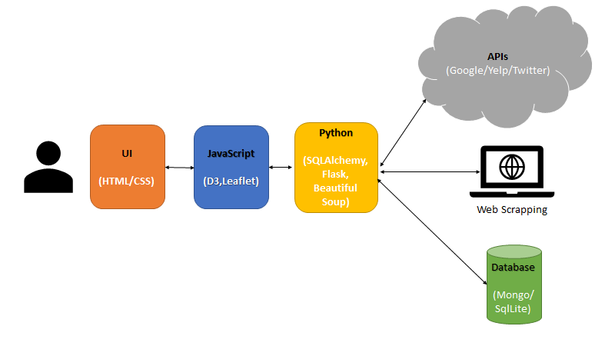

**References**

<https://seasia.co/2018/01/27/the-coffee-belt-a-world-map-of-the-major-coffee-producers>

<https://www.kaggle.com/datasets?sortBy=relevance&group=public&search=coffee&page=1&pageSize=20&size=all&filetype=all&license=all>

<https://quickstats.nass.usda.gov/>

<http://www.ico.org/new_historical.asp?section=Statistics>

